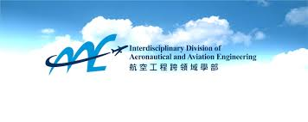THE HONG KONG POLYTECHNIC UNIVERSITY

**Interdisciplinary Division of Aeronautical and Aviation Engineering**

**ENG 1003 Class A (20201)**

**Group project report**

**Group Name:**  AAE pm6

**Student Names:**  Lee Shi Shing (20050272D)

Chan Tsz Hin (20060867D)

Lai Hoi Kit (20049312D)

Yip Tsz Chun (20063211D)

Ho Ho Yin (20042322d)

**Lecturer**  **:**  Dr Li-Ta Hsu

**Due Date :** 12/11/2020

**Background of Path Planning to Aviation Engineering**

It is known that path planning is a computational way to find the sequence of valid configurations that moves the object from the source to destination. It plays a vital role to the aviation engineering. The importance of the path planning to our industry can be shown in safety, time consuming and commercial aspects in the following.

Path planning is highly important as it ensues safety. This can be explained in two critical aspects, fuel consuming and the air traffic management. It’s prerequisite to have an accurate fuel calculation so that the plane can arrive the destination safely. Contingency fuel should also be calculated in the path planning to avoid accidents. To account for additional fuel consumption caused by wind, routing changes or ATM: ATM / CNS constraints, contingency fuel is carried. According to ICAO Annex 6, the recommended minimum contingency fuel is determined based on the calculated arrival weight, greater than 5 percent of the trip fuel or 5 minutes keeping consumption at 1500 'above destination airfield elevation. Some regulators, however, have abolished the minimum time requirement and some in their National Regulations have expanded the recommended time interval. Also, with the use of alternates and based on demonstrated performance requirements from the operator, some regulators allow contingency fuel reduction to 3 percent of trip fuel, or specific time increments. [1]

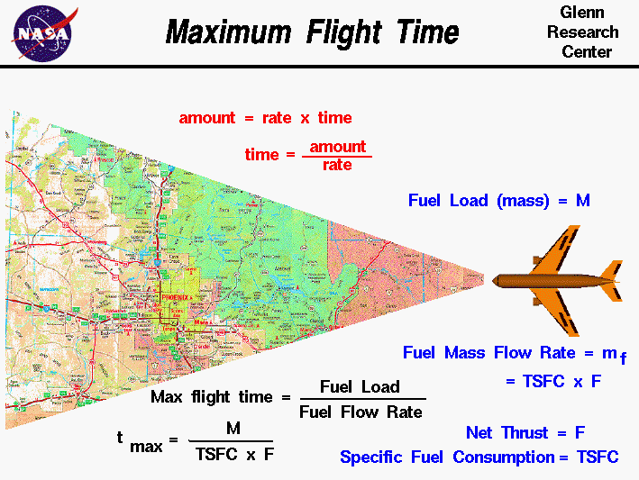(Fig.1)

It’s one of the examples for what path planning should require for the safety issue.

Apart from the fuel calculations, there should also be also have the safe and least delay path be planned. For realistic purposes, the scale of planning is always up to one million square kilometres, and the environment of the planning area is very complex. In addition to the topographical variables, various constraints such as aircraft manoeuvrability, penetration criteria, and flight missions need to be addressed in the planning process. We may also consider about the weather conditions for one of the points of path planning. [2]

Adverse weather conditions can be faced by civil aircraft. Because of the weather disruption, several fatal airplane accidents occurred. In addition, to avoid the banned field we should also plan routes for the safety issue. Therefore, a successful algorithm for road planning plays an increasingly important role in the management of air traffic. To ensure the safety of cabin crews and passengers, an effective route planning algorithm will help the aircraft avoid extreme weather conditions, restricted areas and moving barriers. In addition, the path with the lowest energy cost can also be identified by our algorithm. As a result, path planning can improve the safety operation of the airplanes and reduce the workload of pilots and air traffic controllers.

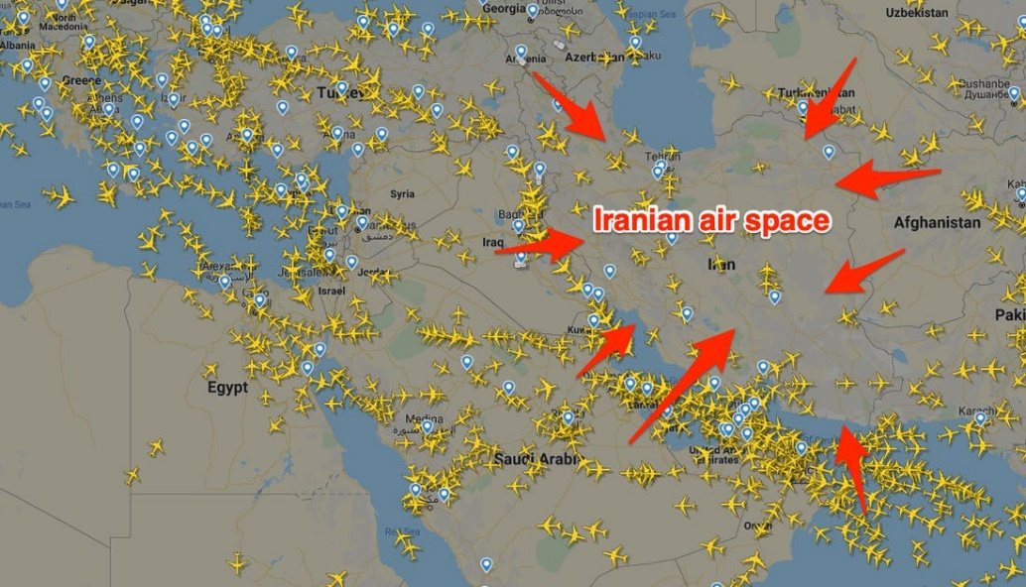(Fig.2)

Besides having an accurate path planning, it can also avoid mid-air collision. As we know there are thousands of aircraft landing and taking off in airports, having an accurate planning can avoid happen of accidents. Moreover, if we mistakenly get into some private airspace, we might also get into some troubles. Because of that, having a path planning before taking off is prerequisite for the airline.

**Theory of Path Planning Algorithm:**

Path planning is widely use in the world. People in many industries, such as aviation industry, automatic car industry, also use path planning algorithm. The purpose of path planning is to find the most optimal path with the lowest cost and also the lowest time consumed. In this project, we use path planning algorithm in aviation industry, which means we use Path Planning Algorithm to find the most optimal route for an aircraft. Path planning algorithm is very important in aviation industry. It ensures the safety for the aircraft after taking off or before landing, which provides a route that will allow the aircraft to bypass all the blockages, including infrastructures or high mountains. On the other hand, path planning also maintain the profit for the airline company, since it will generate a path that has the lowest cost for each journey.

Path planning algorithm helps people to plan the best flight route by inputting several data into the computer. We have to input data such as the fuel cost and time-consuming area, the computer will generate a result that is the shortest path which bypass all the blockage, and also generate a cost for the route. We can compare different aircraft cost by computing different data into the program, so we can know which aircraft and which route attain the lowest cost and shortest path, which is called high efficiency path.

We can find the shortest route by A Star Method. The A star algorithm has 3 parameters:

g : the cost of moving from the one cell to another. Basically, it is the sum of all the cells that have been visited since leaving the first cell.

h : also known as the heuristic value, it is the estimated cost of moving from the current cell to the final cell. “h” is the estimated cost since the actual cost cannot be calculated until the final cell is reached. We must make sure that there is never an over estimation of the cost.

f : it is the sum of g and h. So, “f = g + h” [3]

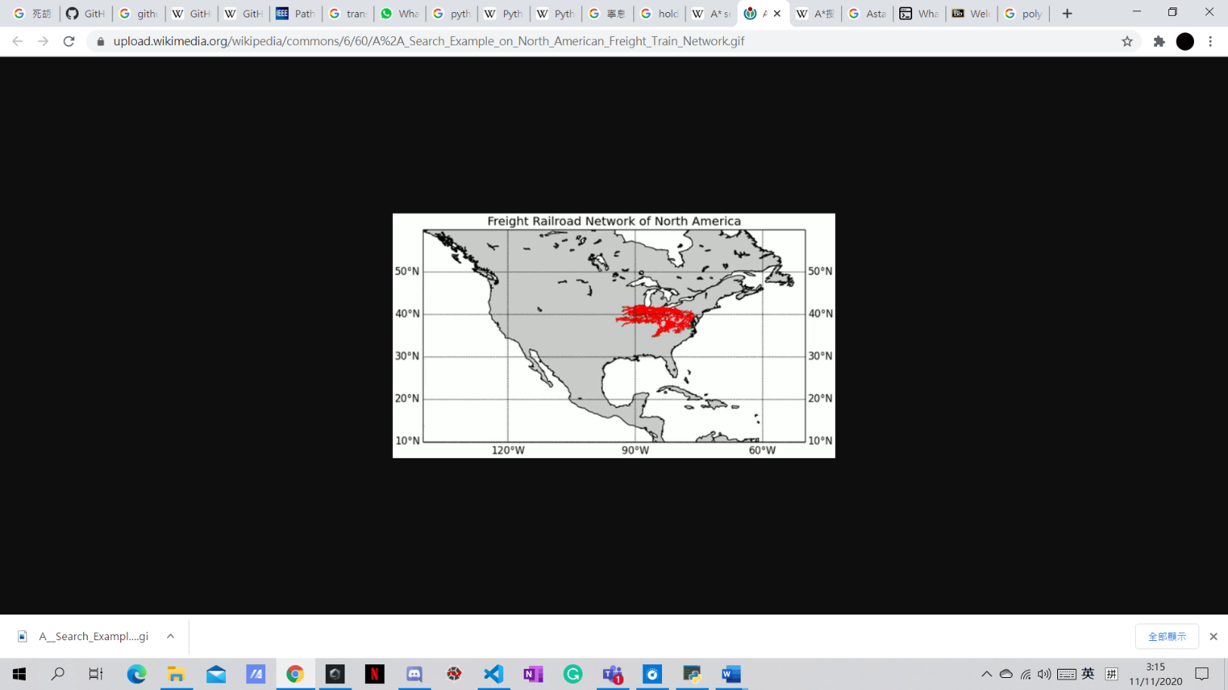The way that the algorithm makes its decisions is by taking the f-value into account. There are 8 neighbouring nodes around the starting node. By selecting the smallest f-valued cell, the algorithm picks that cell as the next cell. After that, that cell will also have 8 neighbouring nodes. This process continues until the algorithm reaches its goal cell. Hence, we will have the shortest route.

That’s all how A-star algorithm works. This would be amazing when we use this method into the real world.

[Fig.3]

**Introduction of the Engineering Tools:**

**Python:**

Python is a popular programming language created by Guido van Rossum and released in 1991. Python is a software that allow you to write a program and then give outputs. Python is a user-friendly tool for people who use it for programming. According to official Python website, it stated that python is a high-level built in data structures, combined with dynamic typing and dynamic binding, make it very attractive for Rapid Application Development, as well as for use as a scripting or glue language to connect existing components together. [4]

There are a lot of advantages in using python. Comparing to other software that allow users to input programs in it, python is relatively easy to read, learn and write since python is a high-level programming language that has English-like syntax.[5]

Python also allow users to gain a higher productivity. Python use simple English as their syntax, it is very easy to understand what does each syntax’s function. Users can focus on solving the problem in the program instead of spending so much time in understanding the syntax or the of the programming language.[5]

Interpreted language is used in python. Interpreted language means that Python directly executes the code in every line. If there are any mistakes that are made by the user, it will stop further interpretation and report the error where it has occurred. Python also show only one error even there are multiple error in the program, which makes debugging easier for the user. [5]

Python also has an extensive support library. These libraries include many areas, such as string operation, web service tools and protocols. [5] Most of the frequently used programming tasks are scripted into these libraries so that users can use it easily. [Fig.4]

Due to its large amount of advantages and user-friendly items, many software development companies also prefer using Python instead of other programming software.

However, there are also some weakness in python. Python has a relatively slow speed in generating results from the program. Since python is an interpreted language and dynamically typed language, the line by line execution of code leads to slow execution. [6] Python has to do extra work instead of only interpreting the result based on the program inputted by the user, so the python will run in a slower speed among other programming tools.

Another weakness is the mobility.[6] In the modern society, everyone has their own mobile phones. They use their phone to make phone calls, receive messages or even work. For some users that work based on python, it is very inconvenient for them because python is only available in computers, which means users of python cannot use their mobile phones to input codes into it.

**GitHub:**

Someone may ask what is GitHub, actually GitHub is a hosting platform where developers and programmers can upload and collaboratively work to enhance the code they make. Its robust version control system is a defining feature of GitHub. Without changing the program, itself or compromising the experience of any existing users, the version control enables coders to tweak software, possibly fixing bugs or enhancing performance. Proposed improvements after the proposals are reviewed and accepted will easily be merged into the live software. [7]

We have learned the online coding collaboration GitHub through this project and here are the reasons why we should use GitHub as our tool to complete our project.

First of all, one of the reasons that why we should use GitHub is that we could use code sharing through GitHub. To be really specific about exactly what GitHub is, to share with different people, it is a file or code-sharing service which can be seen on the PowerPoint. For working on source code, GitHub is the place to be. It is filled with resources that help you write code well, share it, and work together on a code base with our groupmates. [Fig.5]

Moreover, we can track those changes across versions. In a change log, GitHub records changes, so you can know exactly what's changed each time. This function is particularly useful for looking back in time and recognizing changes made by your group mates group mates quickly. From the PowerPoint we can also know that if more than one person is working on a project, it is very useful and helpful. For instance, a team of software developers needs to create a website, and while working on the project, everyone has to update their codes simultaneously. In this case, GitHub lets them create a centralized repository where the code files can be uploaded, modified and managed by anyone. For the collaboration part, a branch is a point-in-time duplicate of the main branch of the project that can be worked on in isolation and then combined back into the branch of our project. Branches allow collaborators to work separately without stepping on each other’s’ code, and to test their changes against the main branch to resolve any conflicts before merging their contribution into the project. [8]

As we may know those above information why we should use GitHub, let’s talk about some history of GitHub. On 1 October 2007, production of the GitHub platform began. The site was launched by Tom Preston-Werner, Chris Wanstrath, and PJ Hyett in April 2008, after being made available as a beta release a few months earlier. In late 2007, when Chris and Tom began my working on GitHub, Git was widely unknown as a framework for version control. GitHub was created to provide developers the option to host code securely and manage commits to code in proper manner. GitHub 's adoption to manage open source projects quickly grew rapidly when paying git hosting became a viable choice and paid subscriptions made the project profitable. Using Ruby on Rails and Erlang, the program that runs GitHub was written. Today, almost everyone hosts their open source projects on GitHub, including top organizations such as Google, Facebook, Twitter, and even Microsoft. Google's new-age Go programming language is housed on GitHub, and it's completely public. Thanks to GitHub, developers have a forum to show the world their skills and work and preserve the status in the industry. They are able to develop their credibility in the programming community by increasing the stars on the repositories there. Also, businesses today want to look at the GitHub profile of prospective workers and contributions their made to big open-source projects. [9]

**Task 1**:

**Methodology**:

In the aviation industry, it is very important to find which route or even which plane has the highest efficiency. High efficiency means that we have to choose the best plane model which cost the least amount of money throughout the journey. There are many factors that affect the final cost of the plane after every journey, such as the cost of fuel per kilogram, the time related cost per minute of flight, fixed cost independent of time. All these factors will make the cost of journey fluctuate.

In this task, we have to find the best aircraft model among the four PolyU aircraft models, PolyU A380, PolyU A381, PolyU A382 and PolyU A383, that achieve the minimum cost for the path. The data of the aircraft are divided into 7 constraints: the cost of fuel per kilogram, time related cost per minute of flight, fixed cost independent of time, trip fuel, the trip time, additional time and additional fuel. Since there are four different PolyU aircraft have been given, which have different data in different constraints of the cost of the journey, we have input 4 different sets of data into a program that is for path planning in python. The python then generates different sets of the final cost, so we can deduce which aircraft will achieve the minimum cost among the rest.

**Result**:

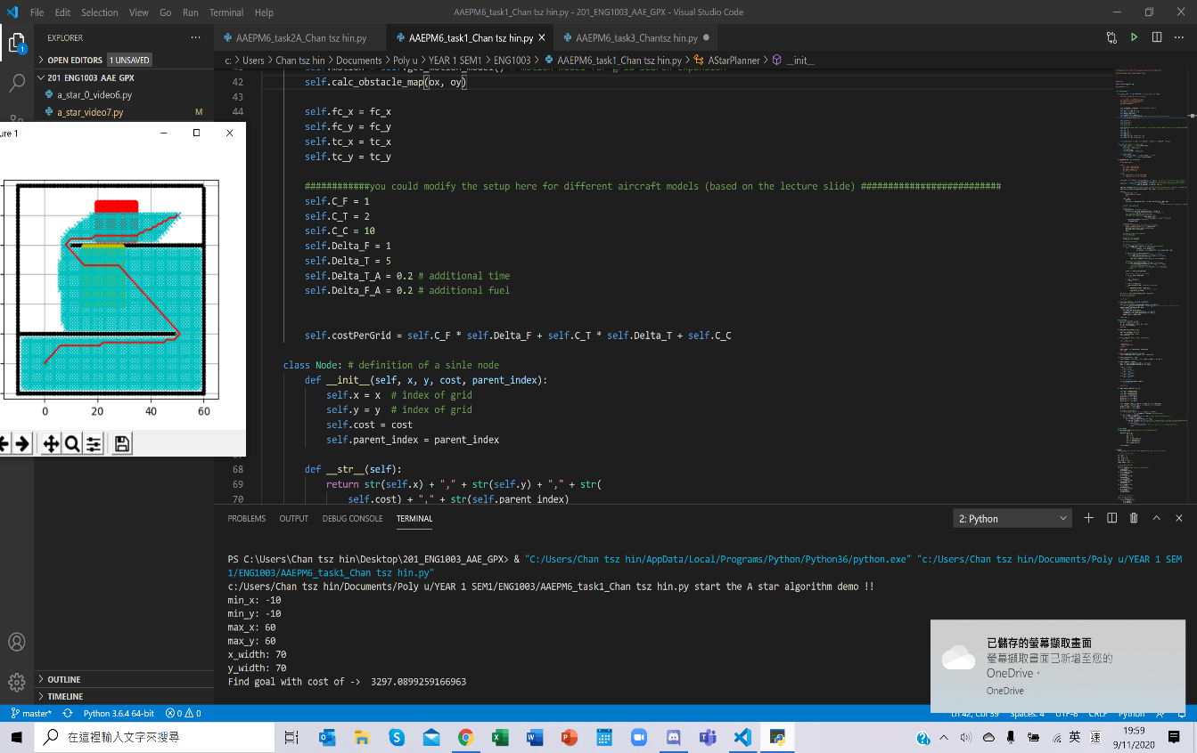

After inputting the four sets of data given, we found that the aircraft PolyU A380 has achieved the minimum cost for the trip.

For aircraft PolyU- A380 model, the data are:

1=cost of fuel per kg

2=time related cost per minute of flight

10=fixed cost independent of time

1=trip fuel

5=trip Time

0.2=additional time

0.2=additional fuel

In aircraft PolyU- A380 model, the final cost that is output by the computer is approximate to 3297 dollars.

**----------------------------------------------------------------------------------------------------------------**

For aircraft PolyU- A381 model, the data are:

1=cost of fuel per kg

3=time related cost per minute of flight

10=fixed cost independent of time

1.5=trip fuel

5=trip Time

0.4=additional time

0.3=additional fuel

In aircraft PolyU- A381 model, the final cost that is output by the computer is approximate to 4163 dollars.

**----------------------------------------------------------------------------------------------------------------**

For aircraft PolyU- A382 model, the data are:

1=cost of fuel per kg

4=time related cost per minute of flight

10=fixed cost independent of time

2=trip fuel

5=trip Time

0.5=additional time

0.4=additional fuel

In aircraft PolyU- A382 model, the final cost that is output by the computer is approximate to 5028 dollars.

**----------------------------------------------------------------------------------------------------------------**For aircraft PolyU- A383 model, the data are:

1=cost of fuel per kg

5=time related cost per minute of flight

10=fixed cost independent of time

2.5=trip fuel

5=trip Time

0.1=additional time

0.5=additional fuel

In aircraft PolyU- A383 model, the final cost that is output by the computer is approximate to 5886 dollars.

As a result, from the above data that are output by the computer, we know that the aircraft PolyU- A380 has achieved the minimum cost at only 3297 dollars in the entire route.

Discussion:

In this task, we act as an airline company. Airline companies do path planning carefully in every single route. They will choose the best aircraft that minimize their expenses, so they can get a higher profit from every trip. However, in this task, the data of the aircraft model are fixed, which limited the minimum cost of each plane. The aircraft may achieve even lower cost when there are new data. Therefore, in the task below, we have conducted some test that aims to let the aircraft PolyU- A380 to attain a cost that is even lower than 3297 dollars.

Task 2.1

**Methodology:**

Although the POLYU-A380 in the above task had achieve the lowest cost on the path among the given aircraft models, and path planning of the aircraft could be done to find the lowest cost route, that is not enough. In the reality, not only aircraft manufactories like Boeing, Airbus and Bombardier trying hard to invent more and more efficient aircraft models, the aviation engine brands, such as Rolls Royce, General Electrics, are also doing their best to cut down fuel consumption on their latest engine models. It is not hard to find out that, both aircraft manufactories and aviation engine brands always use “the most fuel-efficient aircraft/ engine” as their selling point. Actually, due to the rareness of the fossil fuel, the crude oil has always been expensive, each drop of petroleum counts dollars. Therefore, find the more efficient is one of the most important topics in aviation industry.

Based on the result on task1, the flying cost of the POLYU-A380 in our unique map is $3297. In this task, we are aimed to introduce a brand new PolyU Aircraft model, named POLYU-A156, based on the following 3 constants,

• 𝐶𝑐=fixed cost independent of time = 10

• ∆𝐹=trip fuel= 5

• ∆𝑇=trip time= 5

The formula of the Cost C = 𝐶𝐹 ∙ ∆𝐹 + 𝐶𝑇 ∙ ∆𝑇 + 𝐶𝐶

And based on the 6 constraints:

𝐶𝐹>0 and 𝐶𝑇>0

𝐶𝑇 − 𝐶F ≤ 30

−0.5𝐶𝑇 − 𝐶F ≤ −30

2𝐶𝑇 − 𝐶F ≥ 20

−4𝐶𝑇 − 𝐶F ≥ −220

That left us all we need to find are the magnitude of CT and CF which combined make the Cost the lowest. At the very beginning, we tried to use the simultaneous equation method, combining the (𝐶𝑇 − 𝐶F ≤ 30 and −0.5𝐶𝑇 − 𝐶F ≤ −30) together and (2𝐶𝑇 − 𝐶F ≥ 20 and −4𝐶𝑇 − 𝐶F ≥ −220) together. We got a few result on CF: CF ≥ 10 and CF ≥ 10 and CF ≤ 60 and CF ≤ 80. As a result, **10 ≤ CF ≤ 60.**

However, this makes the calculating more complicated. With 51 integers and almost the infinity possible values, we realized this is not quite possible to just input all values in between 10 and 60 into the constraints and calculate again and again. Still, we tried 2 value, 10 and 60. When CF =10, CT ≥ 15 and CT ≥ 40nd CF ≤ 40nd CT ≤ 52.5. When CT =60, CT ≥ 60 and CT ≥ 40nd CT ≤ 40nd Ct ≤ 90. In both calculation, CT=40. Therefore, we first thought the CT has to be 40 and CF should be 10.

However, we are not totally sure whether we could so easily find the answer. So we tried one more combination, CF=30. When CF =30, CT ≤ 0 and CT ≥ 0 and CT ≤ 32.5 and CT ≥ 5. It is rejected since there are conflict between CT ≤ 0 and CT ≥ 5. We realized the solution is far more than what we already solved.

**Results**:

Therefore, we decided to use GeoGebra, by inputting all the constraints, and let y = CF while let x = CT, we have the following graph.

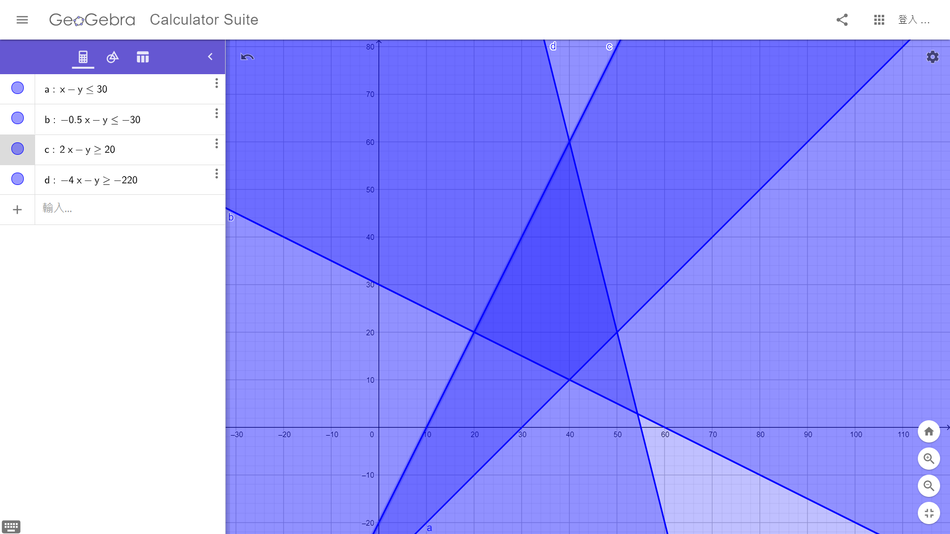

In the left corner, the values are CT = 20 and CF = 20.

While in the bottom corner, the values are CT = 10 and CF = 40.

By substituting CT = 20 and CF = 20 into formula of the Cost C = 𝐶𝐹 ∙ ∆𝐹 + 𝐶𝑇 ∙ ∆𝑇 + 𝐶𝐶 and input the values into Python via VS CODE, the Cost = $33063.38454054119

By substituting CT = 10 and CF = 40 into formula of the Cost C = 𝐶𝐹 ∙ ∆𝐹 + 𝐶𝑇 ∙ ∆𝑇 + 𝐶𝐶 and input the values into Python via VS CODE, the Cost = $40898.91844647395

Therefore, the answer are CT = 20 and CF = 20, while the Cost = **$33063.38454054119**. Our own designed aircraft POLYU-A156 is modified.

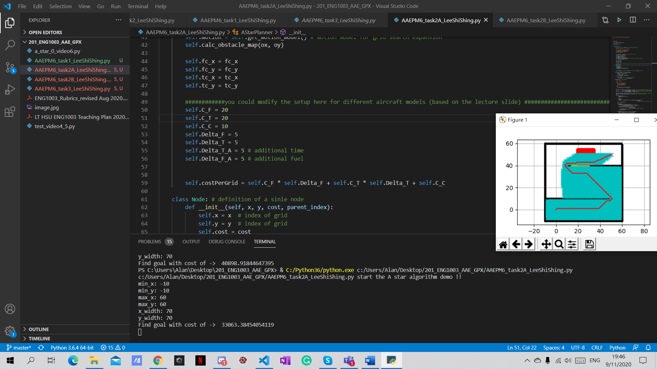

**Discussion**:

From this task we could see a few things.

-Even there are 2 variables, the difference of result could be huge.

-Even the magnitude of some variables has only changed a little, it still could made quite a different result

-The model has to be accurate instead of using similar values

Therefore, we have learnt that in aviation industry, the Engineers are trying their best to modify tiny error, just hope to get the very best model of what they have designed. Little difference could cause a huge loss.

**Task 2.2**:

**Methodology：**

Only two variables in task 2.1 could barely change final result value and find the most efficient aircraft model, the POLYU A156 is not good enough in order to have the lowest route cost. Therefore, in task 2.2, we have more freedom, we have more variables and also align with some constraints. Therefore, we could find a more efficient/ lower cost aircraft running in to the route of task 1. However, it also means that we will face a much difficult question and we have to solve it.

In task 2.2, we have to introduced a brand new aircraft model, a more advance model from our previous model POLYU A156, Therefore, we started to develop a new aircraft model, named POLYU A166, based on the following only constant.

• 𝐶𝑐=fixed cost independent of time = 10

The formula of the Cost C = 𝐶𝐹 ∙ ∆𝐹 + 𝐶𝑇 ∙ ∆𝑇 + 𝐶𝐶

And based on the 5 constraints:

All Variables > 0

CF x DF + CT x DT ≥ 25

𝐶𝑇 + 𝐶F ≥ 10

DT + DF ≥ 10

DTa + DFa ≥ 10

At the beginning, we tried to use the final method used in task2a, inputting constraints into the online graphic calculator. However, there are so much variables for the online calculator to handle. Therefore, this method are quickly banned.

Then we started the old school way. We tried to use simultaneous equation method, combining the 4 constraints. But we soon realized that 2 variables, DTa and DFa are not linked to the other variables via equations. Other than that, the other 4 variables are linked with only 3 equations, mathematically, this couldn’t be solved. This is when we stuck into the dead end.

However, we suddenly thought another method, which is worth a try. First of all, It is assumed that 𝐶𝐹 and 𝐶T are 9 and 1 respectively. Then, using python, different results of 𝐶𝐹∆𝐹 + 𝐶𝑇∆T are presented. In this calculating process, fixed number of 𝐶𝐹 and 𝐶T and variable numbers of ∆𝐹 and ∆T are grouped.

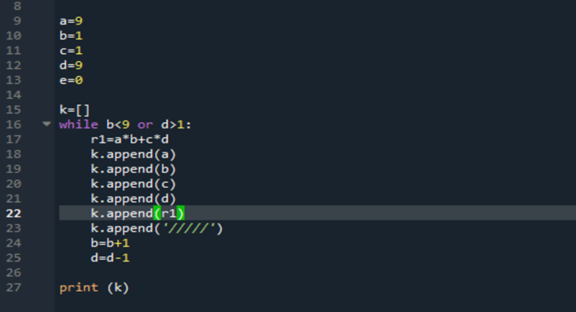

**Results:**



For each group of numbers, first number: 𝐶𝐹, second number: ∆𝐹, third number: 𝐶T, forth number: ∆T, fifth number: result of 𝐶𝐹∆𝐹 + 𝐶𝑇∆T

As a result, we found that the following final answer:

CF = 1

CT = 9

Which CF + CT = 10, **attained the minimum**.

DF = 8

DT = 2

Which DF + DT = 10, **attained the minimum**.

The constraints CF x DF + CT x DT = 26,

which just **higher than the minimum by 1**.

DFa = 1

DTa = 9

Which DTa + DFa = 10, **attained the minimum**.

By substituting CT = 9, CF = 1, DF = 8, DT = 2 into formula of the Cost C = 𝐶𝐹 ∙ ∆𝐹 + 𝐶𝑇 ∙ ∆𝑇 + 𝐶𝐶 and input the DFa = 1, DTa = 9 and the other values mentioned above into Python via VS CODE, the Cost = **$5792.412839396318**

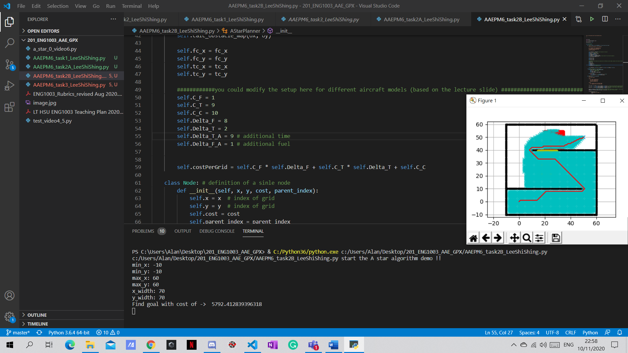

We have also tried to change all variables by plus or minus one, and the fact shows that the above result could make the minimum cost.

|  |  |  |  |  |  |  |
| --- | --- | --- | --- | --- | --- | --- |
| ∆T𝑎 | 9 | 8 | 7 | 3 | 2 | 1 |
| ∆F𝑎 | 1 | 2 | 3 | 7 | 8 | 9 |
| Total cost | 5792.4 | 5793.2 | 5794.1 | 5797.4 | 5798.2 | 5799.0 |

From the result, it is deduced that the simultaneous decrease of ∆𝐹𝑎 and increase of ∆𝑇𝑎 are results in an increasing overall cost. Therefore, it is concluded that when ∆𝐹𝑎=9 and ∆𝑇𝑎=1, the cost can be minimized.

Therefore, the POLYU A166 is modified.

**Discussion:**

-it is complicated to obtain the most appropriate value of ∆𝐹𝑎 and ∆𝑇𝑎 by separate calculation

-in real case, the parameters of an aircraft are not that accurate as those provided in task 2, but the one who design the path should obtain the data as accurate as possible for calculation.

-using program for the complicated calculation can make it simpler and more convenient.

**Task 3:**

**Methodology:**

Task 3 is about to create one more area that able to reduce the cost when the plane pass by. To reach this purpose, the first step is to find out the way that how to add more cost in time-consuming-area and fuel-consuming area.

Using the python codes of star path planning, the codes indicating the function of adding more cost to a certain area present.

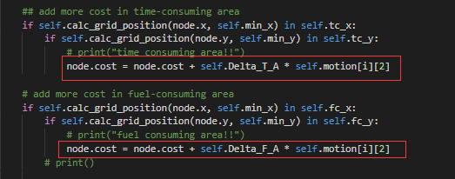

The lines in the red border are the calculating process of adding cost.

Then, the second step is to create an area via python. Using the python codes of star path planning, the codes indicating the function of setting a certain area present.

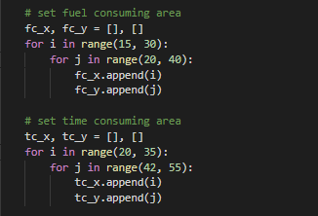

After searching for the previous codes that involved variable fc_x, fc_y, tc_x and tc_y, new variables are created with reference to the original format.

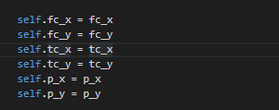

Next, since it is prepared for setting the new area, the shape of the area is taken into consideration. Refer to the requirement, the maximum size of the minus-cost area is 16m2 (16 grid points). The simplest way is to create a linear area with 16*1 size covering the route of the plane.

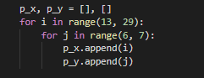

Plot the blue area with the code:



Finally, a blue area is presented.

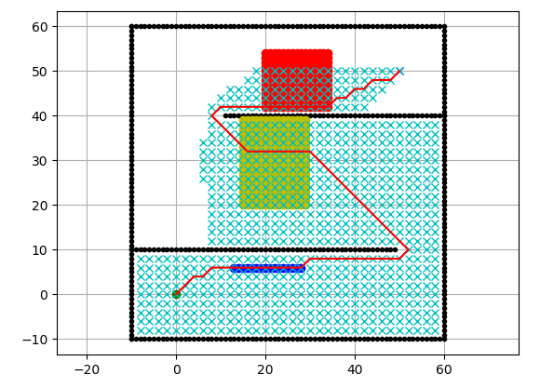

The next step is refer to the first step, which is to find out how to add more cost in a certain area when the plane pass by. After searching for the involved codes of self.Delta_T_A and self.Delta_F_A, new variables of self.C_P and self.Delta_P are created with reference to the original format.

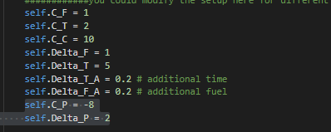

Since the given calculating formula for the cost of each grid is C = 𝐶𝐹 ∙ ∆𝐹 + 𝐶𝑇 ∙ ∆𝑇 + 𝐶𝑐 + 𝐶𝑃 ∙ ∆P, the codes of adding cost in certain area is altered like this form. 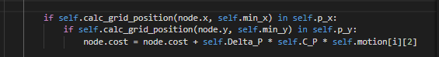

**Testing:**

set the C_P and Delta_P be 0, the total cost is 1669.46.

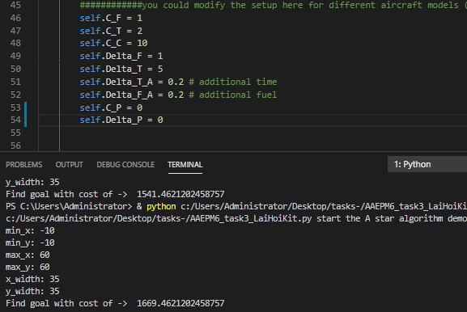

Set the C_P and Delta_P be -8 and 2 respectively and p_x and p_y be 0, the total cost is also 1669.46.

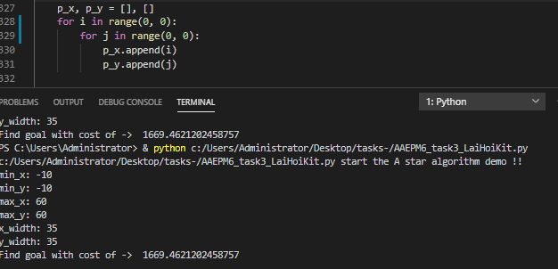

Set the C_P and Delta_P be -8 and 2 respectively and p_x and p_y be range of 13-29 and 6-7 respectively, the result is decreased to be 1541.46.

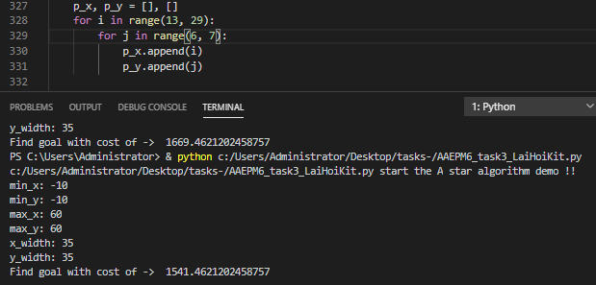

As a result, the cost only decrease when the minus cost area present and cover the route of the plane. The minimum cost can be reached with the linear shape that mostly cover the route.

Therefore, after creating a new cost-cut zone, the minimum cost we could reach would be **1541.46.**

**Results :**

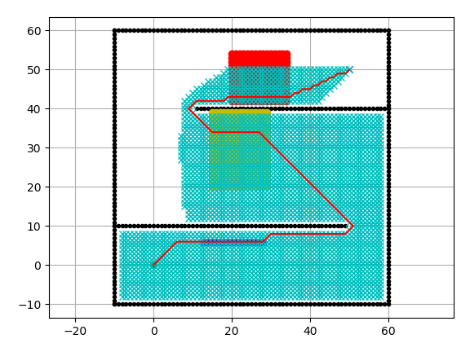

The final result after inserting a minus cost area with grid size of 1 is 5666.768. The parameters involved are same as the results of task 2.2.

Comparing to the total cost without minus cost area, which is 5730.768, the cost with minus cost area is less for 64.

**Discussion:**

It took 2 times to reach the final purpose. In the first try, I misunderstand the program and alter the wrong codes for calculation.

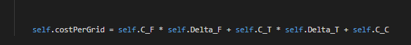

Additional cost was added in this line. After that a test was taken. It showed that even if the minus cost area was defined as 0 to 0 or the parameters of the minus cost area is 0, the cost was reduced. It is deduced that the cost was reducing in each gird in the route. Therefore, the above line was corrected to the original states and the purpose is much more clear, which is to make the cost reduced only if it pass by the minus cost area. Then after looking for the set of codes with the funchtion of adding more cost in both time-consuming area and cost-consuming area, a new codes were added with the similar format. The result after testing was satisfactory. The specific details can be seen as the above content.

Through this small-scale debugging, we learned to read a program and find the function of different sets of codes more efficiently. Besides, we know more about the operation principle of adding or reducing cost in a certain area. For an aircraft, some parameters like cost of fuel per kg and time related cost per minute of flight are fixed, when it pass through a certain environment which is affected by variable factors such as weather, it will takes more or less cost. For the minus cost area created in task 3, it is most likely to be the jet stream winds in troposphere with high wind speed. It may ‘push’ the aircraft and the thrust required in aircraft can be reduced. Accordingly, the overall cost required to pass by this area decrease.

**Reflective Essays:**

Lee Shi Shing:

Although I could choose a totally different engineering subject in the freshmen seminar project, I still choose the AAE one. Not only because I like my own major subject - Aviation Engineering, but also because I like aviation and I would like to learn more about it. Before the freshmen seminar project, I have never ever realized that path planning is so important to the aviation industry that the profit of the industry would seriously affect by this.

Coding is one of the other aspects that I have never ever learnt. Before the lectures, I totally don’t familiar or not even know what is GitHub and what is Python. Now I have learnt that GitHub, the largest host of source code in the world, is a very useful online sharing platform for me now. I could easily share files, codes via GitHub and modify the documents and gits of my friends through GitHub. Also, GitHub would be a large source of program where I could find others free giving work which could enhance my own Python coding skills. And Python, more than a coding style, I could say a language for computer. Python is far more difficult than what I expected. I have learnt about A-Star Path Planning Method, how it works and how we should do. I have learnt how to set obstacles, neighbor node search, calculate the cost and finally press the cute green little play button. That is amazing when I could run a program by inputting alphabets and numbers. Also, in the tasks, modifying the codes and variables are so exciting that I hold my breath while waiting the figure run. Every time I was very looking forward to whether the cost would be lower or not, this is how the project attract me the most.

Path planning is very important to the aviation industry, and so do efficiency of aircraft. Through this project I have learnt that the small difference in some values which modified the aircraft model, large difference of the final result (cost). Therefore, engineers are desperate to modify the tiniest mistakes in order to create the best result. Creating the best aircraft model and engines could be the aim of the major civil aircraft manufactories and engine manufactories. Therefore, other than flying a plane or creating the airport, modify efficient aircraft model and path planning are also very important aspects in aviation engineering.

This project truly makes me learnt so much!

Chan Tsz Hin:

After finishing this freshman seminar project of the aviation engineering department, I understand that the aviation industry is not as easy and simple as what we think, it is much complicated and this industry requires a lot of different departments to cooperate.

In this project, we are required to use python to generate different outputs by entering some sets of data into the program provided. As an ordinary passenger that travels around the world easily by just clicking some buttons on the internet to purchase an air ticket, I didn’t realize that behind the flight take off, there are a bunch of processes have to be done by different people. Throughout this project, we act as one of the sectors in the aviation industry, the path planning sector. Path planning is very important to the airline safety and also the revenue for an airline company. Aircrafts may face a lot of infrastructures or mountains when they are flying in the sky. We have to plan a path for the plane to go around these blockages and land or take off safely. There will be many paths generated because there are different paths that can lead the plane to escape from the blockages, so we have to find the shortest route to reduce the cost for the journey since a longer route may result in higher fuel consumption.

We also have to calculate the cost of the routes, even for those which is already the shortest route, some route may contain a higher cost consuming area while some do not. The cost will be greatly reduced if we can select the correct path, where the airline company will get a better profit by that route.

We are instructed to upload our work that we done in python to GitHub to share our work to our groupmates and instructors. This is the first time we use this two different software, so it brought a number of difficulties to finish our tasks. We neither know how to use python to generate our answers for the tasks nor uploading our results to GitHub in the very beginning. However, with the help from our groupmates and our teaching assistant, we finally know how to input suitable values into the program and get various answers for our project. This project gives me a useful experience in using python and know more about the aviation industry.

Lai Hoi Kit:

Though this project, I realize that path planning for aircraft operation is crucial in the past, present and the future. Accordingly, the path planning algorithm have to be rigorous and presenting a high adaptibility to different environment. I have just learned the basic knowledge of how a path planning aigorithm look like and how it works to reach the minimum cost with alterable parameters. The real design of path planning is much more complicated as there are many components in an environment that must be taken into consideration like the routes and the number of planes in the same airspace and the weather change. The design should prevent every potential accidents in the aircrafts’ routes.

**Github:**

Github plays a important role in this project. In my opinion, Github is a convinient tool to share the codes with each others and consult others’ codes works as there are plenty of open-source codes in Github. Through this project, I learned how to upload an image and codes to the repository in Github. The procedure is like, first, select the folder with the uploading files inside, then, build a linkage between the computer with the network and ‘push’ the files to the desired branch in the repository.

Github allows me to see and refer to my groupmates’ works. I can even alter their works if there are something going wrong.

**Python:**

When I was doing the task that I responsible of, I tried to complete the calculating process through python. In task 2.2, I used python to calculate diferent results of 𝐶𝐹∆𝐹 + 𝐶𝑇∆T with the parameters within constraints. For me, the procedure of programming can be divided into five parts. First is to be clear about the purpose, then is to figure out how the python works to reach the purpose. Thirdly, I practically write the programme and after that, I test it. Finally, it is necessary to debug if there is something wrong. For the case of task 2.2, I was trying to make sure different groups of parameters and the result for comparation are presented. Therefore, a simple loop was made.

On the other hand, I learned how to systematically read the codes through task 3. A program can be divided into different part for different function such as plotting a graph and setting the constraints of the path. Furthermore, the searching tool helps to present the roles of a certain variable play in diferent sets of codes. After roughly knowing about how the program works, i can alter the program by adding something with similar format to reach the purpose, which is adding a new minus cost area in task 3.

After the project, I have little aquaintance with python. For an instance, I am much more clear about the usage of the while loops and the function (def). The learning process of this project lays a solid foundation of the learning of python in the future. It also arises my curiosity about programming and make me much more willing to learn python spontaneously.

Yip Tsz Chun:

Personally, I had numerous insights regarding the group project. As a freshman, there were many challenges along the way as I was not familiarized with the setting. However, I am grateful that I have gained a lot when doing this project and I will explain in the following.

First and foremost, I would like to share things I have learnt as an individual which is to better manage my time. I admit that I do not have good time management skills and I procrastinate a lot. I started to do my part of work late and this may have caused trouble to other groupmates as I slowed down the whole team progress. I have taken the lesson and will improve my time management skills when I encounter another project, no matter it is done as a group or individually. I have planned some practical ways to turn the tide. For instance, I will start my day with a “To-Do list” to prioritize the tasks that are urgent, based on the due date and time needed for completion. I hope by having the day planned, my time management skills will be improved.

Besides, I have learnt to seek help from others. This project requires a lot of knowledge, that are far beyond what I have learnt. I have spent time and effort on searching scholar’s articles, reports, books, etc. for this assignment. However, I then understood that I should apply what I have learnt from lessons to another level, which requires a lot of researches and help from expertise. During the preparation period, I have seek assistance from my overseas friends who have already graduated as they are more experienced on this filed. Their helping hand truly guided me through some struggles.

Last but not least, I have learnt to work as a team. I realized that a group is not able to work without the cooperation of everyone in the group. If any of us decided to give up performing the research on the topic assigned, the group will surely fail the assignment. I also found out that although working alone is easier, working with groups can help build my social skills and provide me chance to cooperate with others. It enhanced my communication skills as I pointed out my ideas politely while actively listening to others during discussion.

Overall, I appreciate this opportunity to work with my groupmates and finish the assignment as a team.

Ho Ho Yin:

In this group project, I have learnt that there are many purposes in path planning of aviation other than safety, for example, finding the minimum cost of flight, better view for sightseeing and shorten the flight hours. The purpose of our group project is to find out minimum cost of flight by using Python. I personally have no experience in coding. Thanks to the help of group mates and teaching assistant, I can understand more in coding and how to use them in solving aviation related problems, which is helpful in my future study in the university.

**References**:

[1] Skybrary, Fuel- Flight Planning Definitions, 2018

<https://www.skybrary.aero/index.php/Fuel_-_Flight_Planning_Definitions>

[2] Z. Xie and Z. W. Zhong, MATEC Web of Conferences 77, 15001, 2016

<https://www.matec-conferences.org/articles/matecconf/abs/2016/40/matecconf_icmmr2016_15001/matecconf_icmmr2016_15001.html>

[3] 2020 Educative, Inc , Edpresso, What is the A* algorithm?, 2020

<https://www.educative.io/edpresso/what-is-the-a-star-algorithm>

[4] Python “What is Python? Executive Summary”, 2020

<https://www.python.org/doc/essays/blurb/>

[5] Mildfire Solutions, “Advantages and disadvantages of python programming language” April 24, 2017

<https://medium.com/@mindfiresolutions.usa/advantages-and-disadvantages-of-python-programming-language-fd0b394f2121>

[6] Chhavi kumar, “Python advantages and disadvantages- step in the right direction ” 2020

<https://techvidvan.com/tutorials/python-advantages-and-disadvantages/>

[7] Laurance Bradford, What Is GitHub? -Definition & Examples of How to Use GitHub, 2020

<https://www.thebalancecareers.com/what-is-github-and-why-should-i-use-it-2071946>

[8] Anne Kerr, Using-git-and-GitHub-for-team-collaboration, 2019

<https://medium.com/anne-kerrs-blog/using-git-and-github-for-team-collaboration-e761e7c00281>

[9] Saurabh Mhatre, The-untold-story-of-GitHub, 2016

<https://medium.com/@smhatre59/the-untold-story-of-github-132840f72f56>

[Fig.1] Nancy Hall, NASA- Maximum Flight Time, 2015

<https://www.grc.nasa.gov/WWW/K-12/airplane/ftime.html>

[Fig.2]David Slotnick, Airline are avoiding airspace near Iran,2020

<https://www.businessinsider.com/ukraine-iran-plane-crash-airlines-airspace-avoid-iraq-persian-gulf-2020-1>

[Fig.3] Srossd, Search Example on North American Freight Train Network.gif, 2014

[https://en.wikipedia.org/wiki/File:A*_Search_Example_on_North_American_Freight_Train_Network.gif](https://en.wikipedia.org/wiki/File:A*_Search_Example_on_North_American_Freight_Train_Network.gif)

[Fig.4] Python software foundation, The Python Logo, 2020

<https://www.python.org/community/logos/>

[Fig.5] Mariel Grace, How to Set Up and Maintain a GitHub Repository, 2019

<https://medium.com/coding-in-simple-english/how-to-set-up-and-maintain-a-github-repository-614ec4a1e387>